“Home for All: God’s Heart of Welcome”

Acts 4:32-35

In 2016 I went with my daughter to Dubai to visit my sister. One of the things that my sister wanted us to see is Burj Khalifa as it is the tallest building in the world. One person in our group was wearing pink tennis shoes. When we tried to get a tour of the building, we were only allowed on the first floor but not into the top part of the building. On the one hand, I was relieved as I am afraid of heights. On the other hand, we felt excluded. We definitely did not belong! While this experience was not earth shattering as many people with disabilities feel many times, it came to my mind as I was thinking about the importance of belonging and the many barriers to authentic belonging.

We have been talking about home and our sense of authentic belonging since September of 2024. And now we get a little deeper into this human need from a faith perspective, especially as it relates to God’s heart of welcome for all of us.

Dr. Erik Carter, the Executive Director of the Baylor Center on Developmental Disabilities, did some research for several years where they interviewed young adults with disabilities and their families. They also surveyed 500 families about their experiences within their faith communities. Their research extended to a lot of leaders and churches around this issue of belonging for people with disabilities. Here is what they found. People “indicated that belonging was felt when they were present, invited, welcomed, known, accepted, supported, cared for, befriended, needed, and loved.”

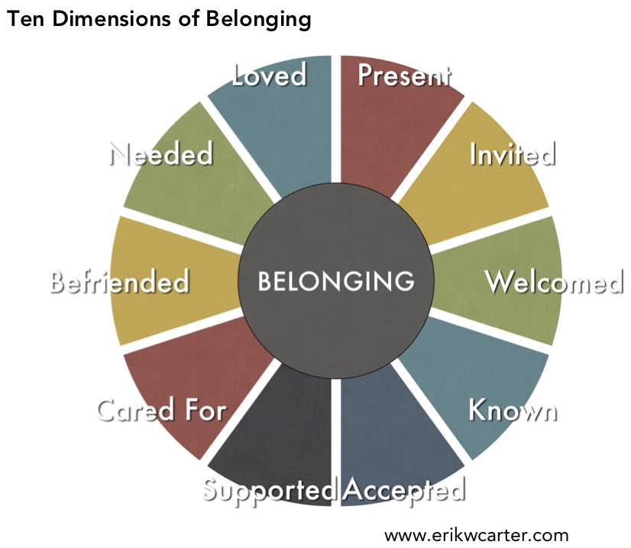

Dr. Carter’s work with people has led him to believe that belonging is not just about a location. It is also about our posture and relationships. So offering others a place of belonging is truly about ordinary gestures more than extraordinary responses.

Consider these ten dimensions! They apply to all of us. We all need these experiences in our relationships in order to feel that sense of belonging. And the church is no different. We can’t look only at the physical aspects of our building such as making the entrances or bathrooms accessible to people who use wheelchairs or having visuals that help those with hearing issues. We can’t just consider inclusion as our ultimate goal. We have to look at true and authentic belonging by always prioritizing relationships. That is how God does it. Throughout the whole Bible, we see God being present to people through their ordinary experiences of life and through the people of their lives from Moses on the mountain to Jesus being the very essence of God in our midst.

Our Bible story for today comes from the example of the early church where people knew that faith was being intentional about building relationships. In order for people to truly belong, they have to be included, welcomed, invited, cared for, needed, and loved, because that is what Jesus modeled for us. He showed us the heart of God and the essence of who we are as children of God.

The early Church continued in the Spirit of Christ to bring people together and to break down barriers. The early Church, as described in Acts 4, practiced their faith in a way that can inspire us today. The early followers of Christ were so focused on the love of God that their lives were so transformed that people felt so welcomed and loved into the community of faith. Motivated by the Holy Spirit, they generously shared their resources and opened their homes and hearts to one another. Their hearts were opened to the needs of others among them. Community became central to one’s life and that community was diverse in every possible way. Everyone belonged and contributed. In their societies and at a time when divisions and class distinctions were paramount, these churches practiced a different way of life where divisions were healed, and each person was supported and encouraged to share whatever gifts they had. Let’s listen to Acts 4:32-35

**32** Now the whole group of those who believed were of one heart and soul, and no one claimed private ownership of any possessions, but everything they owned was held in common. **33** With great power the apostles gave their testimony to the resurrection of the Lord Jesus, and great grace was upon them all. **34** There was not a needy person among them, for as many as owned lands or houses sold them and brought the proceeds of what was sold. **35** They laid it at the apostles’ feet, and it was distributed to each as any had need.



This was a genuine community where people practiced vulnerability, sharing, teaching, and joy. Those who needed help felt like they belonged. Those who were able to give felt compelled to share because great grace was upon them all. Genuine Christian community is about grace, where our social hierarchies, divisions, and hatreds are turned upside down and exposed for their inadequacy to feed our souls.

I want to invite us to consider together how God is calling us, individually and collectively, to grow in our sense of belonging and in inviting others to belong. We are focusing here on people with disabilities, but you can focus on any aspect of our human experience as the Spirit leads you.

Let’s take time to let the Spirit of God bring to our attention those with disabilities both visible and invisible who belong in God’s heart and in our community.

We will close by watching this song which reminds us of God’s heart of welcome:

[Carried To The Table on Vimeo](https://vimeo.com/478656244). Amen.