“Home for All: Whatever It Takes”

Mark 2:1-12

Today we are considering the importance of two dimensions of the ten dimensions that have been identified by Erik Carter about belonging, especially for people with disabilities, namely being supported and cared for.

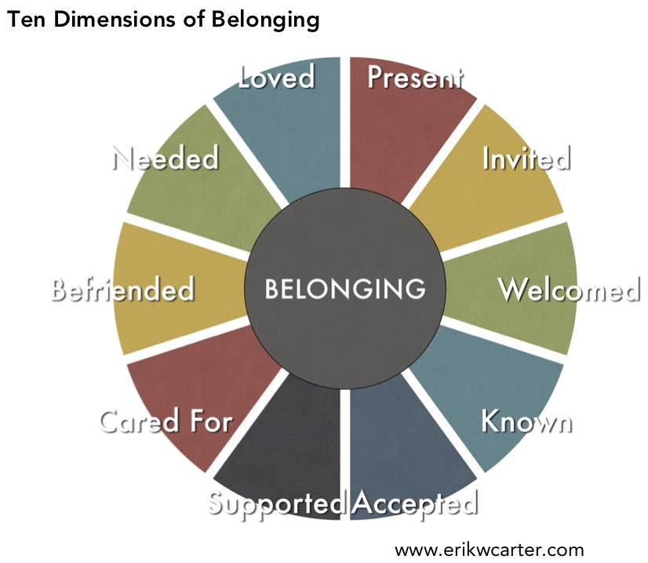

These are two important dimensions of belonging for all of us. Part of feeling at home in a community is knowing that we are supported and cared for because we are all interdependent upon each other. This is a tough sell at times in our culture when many of us learn from an early age that being independent is very important. One example of this is the say, “God helps those who help themselves.” As a pastor I often hear this quoted as if it is a Bible verse. In fact, a survey by the Barna Group found that 81% of Americans believe this very saying is in the Bible. Not only that, but half of those who believe this also believe that this is a foundational message of the Christian faith. In reality, this phrase comes from ancient Greece and Aesop’s Fables. In one of those fables, a man’s wagon falls into a ditch. When he calls out to Hercules for help, “Lift my wheel from where it’s stuck.” Hercules laughs and says, “No such luck. Set your shoulder yourself to the wheel!” About two thousand years later, Benjamin Franklin used the phrase as an ending the Hercules saying, “But God help those who are found helping themselves.”

I am not against people working hard or doing their part in society. What I find incompatible with the Christian faith is when our worth ends up being tied to our ability, especially when it comes to production. Belonging is about recognizing our deep connection to one another in all the circumstances of life.

We get glimpses of this in times of deep need when we are able to step out of cultural barriers to love and support one another. I saw a shining example of that after the plane and helicopter crash over the Potomac River. On a cold winter night, hundreds of rescue workers risked their lives to search for survivors. They braved the icy cold water to care for strangers they didn’t even know. They didn’t check to see if people involved in the accident were deserving or not. They were only driven by compassion and duty of care.

Jesus modeled the same spirit of care and compassion when he healed a man who was paralyzed. But before the physical healing took place, Jesus also offered two spiritual experiences of grace. Let’s listen to the story according to Mark 2:1-12

When he returned to Capernaum after some days, it was reported that he was at home. **2**So many gathered around that there was no longer room for them, not even in front of the door; and he was speaking the word to them. **3**Then some people came, bringing to him a paralyzed man, carried by four of them. **4**And when they could not bring him to Jesus because of the crowd, they removed the roof above him; and after having dug through it, they let down the mat on which the paralytic lay. **5**When Jesus saw their faith, he said to the paralytic, ‘Son, your sins are forgiven.’ **6**Now some of the scribes were sitting there, questioning in their hearts, **7**‘Why does this fellow speak in this way? It is blasphemy! Who can forgive sins but God alone?’ **8**At once Jesus perceived in his spirit that they were discussing these questions among themselves; and he said to them, ‘Why do you raise such questions in your hearts? **9**Which is easier, to say to the paralytic, “Your sins are forgiven”, or to say, “Stand up and take your mat and walk”? **10**But so that you may know that the Son of Man has authority on earth to forgive sins’—he said to the paralytic— **11**‘I say to you, stand up, take your mat and go to your home.’ **12**And he stood up, and immediately took the mat and went out before all of them; so that they were all amazed and glorified God, saying, ‘We have never seen anything like this!’

The first lesson is that of friendship; Jesus recognized the power of the faith and love of the friends who brought their hurt friend to him. They had to be very creative because they cared deeply. That man’s wellbeing and sense of belonging depended on his friends who found a way around all the people so that Jesus would help him. That man was already blessed by having such friends.

The second lesson is about healing whatever keeps people isolated from community and care: Jesus seemingly does an odd thing. Instead of just healing the man, he first declares the man’s sins being forgiven. To appreciate this more fully we need to consider that people at that time and in that culture believed that there was a connection between illness and sin. They believed that if you became ill, especially with a physical disability, you or your family members must have broken the law of God that was given through Moses. To them, sin was not just about a moral failing as we tend to think. It was also about keeping and fulfilling the laws according to the demands of the religious leadership of Jerusalem. This takes some adjustment for us to understand. We tend to think of sin as our moral failings. We have been taught that all of us are born sinful because of Adam and Eve. But in the time of Jesus, sin was not related to that. Sin was defined as breaking the covenant and not following the laws that are given by the priesthood of Jerusalem. This basically meant that if you could not pay the taxes and tributes that were demanded by the temple and the Roman government, you were a sinner. So, most of the peasants in the region of Galilee where Jesus was would have been considered sinners because they could not always live up to the economic demands of their religion. As a result, the peasants were always made to feel responsible for their own malaise and problems. They were not blessed with material wealth because they were cursed by God. They were sinners because they could not afford to fulfill all the requirements of their religion. They blamed themselves for their poverty and illnesses.

By forgiving the sins of the paralyzed man, Jesus addresses the social system that was oppressing the people represented by the paralyzed man. The real miracle of the story is the change in the perspective for the paralyzed man. He was healed from thinking that he was the one to blame for his illness. He was relieved from the burden of guilt and shame to allow for his true healing to take place. The physical healing that he experienced was firmly connected to his spiritual healing. A change of perspective was essential for this healing to take place. Jesus was not only healing one man, he was also bringing healing to a whole community that saw itself as worthless and sinful. They were oppressed by the imperial structures of their day to believe that their poverty and misfortune in life were their own fault. Even illnesses that resulted from malnutrition and poverty were seen as something to be ashamed of. It would not have been enough for Jesus to just heal the man because that was only the symptom of the problem. Even by calling the man “Son” Jesus was taking a major risk. He called him “Son” before the man was even healed, while the rest of society would have isolated him.

No wonder the religious leaders who represented the powers of Jerusalem were upset! The healing was not the part that offended them. It was the forgiveness of sins. They didn’t want the people of the village of Capernaum to get any new ideas in their heads. They did not want them to think that they could just get away from the grip of the power they had held over their heads. The courage of the friends of the paralyzed man to lower him through the roof and the audacity of Jesus to forgive the man’s sins were blowing a major hole in the systems of hierarchy and domination which held the peasants down. Jesus might as well have been saying to them, “Don’t believe what you have been told about your life. You are blessed and not cursed.” The teachings of this story fit really well with the beatitudes which Jesus gave to them, blessing the poor, the sorrowful and the oppressed. What they needed was to be reminded of the goodness of God’s creation in them. That was the power of healing which Jesus was unleashing among his people.

Think of how illness, loss, and our flawed perspectives on disability often keep people isolated. Also, consider our cultural perspectives on dependence and interdependence. This story reminds us that God cares for us and supports us in our times of need and we in turn are invited to participate in this cycle of support by reaching out to others. We are all in this life together. There is nothing shameful or sinful about the essence of who we are when we recognize our need for others to care for us and to support us. Just as we have been taught that helping others is a good thing, we need to embrace with gratitude our need for others to help us. Robin Wall Kimmerer names this concept of “All flourishing is mutual.” That is how God works in and through our lives. This is the truth of our world, and we are invited to live it and remember that there is a home for all of us.

I invite you to ponder this story through a sand painting of it by Harm van Schaik:: <https://fb.watch/xvLFZSLXVH/>. Amen.

**Weekly Bible Devotional**

**“Home for All: Whatever It Takes”**

**February 9, 2025**

**Mark 2:1-12 (NRSV)**

When he returned to Capernaum after some days, it was reported that he was at home. **2**So many gathered around that there was no longer room for them, not even in front of the door; and he was speaking the word to them. **3**Then some people came, bringing to him a paralyzed man, carried by four of them. **4**And when they could not bring him to Jesus because of the crowd, they removed the roof above him; and after having dug through it, they let down the mat on which the paralytic lay. **5**When Jesus saw their faith, he said to the paralytic, ‘Son, your sins are forgiven.’ **6**Now some of the scribes were sitting there, questioning in their hearts, **7**‘Why does this fellow speak in this way? It is blasphemy! Who can forgive sins but God alone?’ **8**At once Jesus perceived in his spirit that they were discussing these questions among themselves; and he said to them, ‘Why do you raise such questions in your hearts? **9**Which is easier, to say to the paralytic, “Your sins are forgiven”, or to say, “Stand up and take your mat and walk”? **10**But so that you may know that the Son of Man has authority on earth to forgive sins’—he said to the paralytic— **11**‘I say to you, stand up, take your mat and go to your home.’ **12**And he stood up, and immediately took the mat and went out before all of them; so that they were all amazed and glorified God, saying, ‘We have never seen anything like this!’

**Mark 2:1-12 (First Nations Version)**

After many days Creator Sets Free (Jesus) went back to Village of Comfort (Capernaum), but word got out that he had returned home. So many people had gathered in the house that there was no more room. Even the entrance was blocked. Creator Sets Free (Jesus) began to teach the people there when four men came carrying a paralyzed man on a sleeping mat, but they could not get past the crowd. In their desperation, they climbed up to the rooftop and broke through the roof right above Creator Sets Free (Jesus). They lowered the paralyzed man down, sleeping bundle and all.

When he saw their faith in him, he said to the paralyzed man, “Young man, you are released from your broken ways. There were some scroll keepers there who began to wonder in their hearts, “Who is this man to speak against the Great Spirit with such disrespect? Who but the Maker of Life can release a man from wrongdoings?”

In his spirit, Creator Sets Free (Jesus) knew right away what they were thinking and said to them, “Why are your hearts full of these thoughts? Is it easier to tell a paralyzed man, ‘Get up and walk,’ or to say to him, ‘You are released from your wrongdoings?’”

“This is how you will know that the True Human Being has the right to forgive bad hearts and broken ways on this earth.”

He turned to the paralyzed man and said, “Get up, roll up your sleeping bundle, and walk home.”

Right away the man stood up, and in front of them all, he rolled up his sleeping bundle, and walked out. Great amazement filled the hearts of all who were in the house as they gave praise to Creator. “Who has ever seen this kind of mysterious and powerful medicine?” they asked.

**Notes on the Text:**

This week we focus on two dimensions of belonging which were identified by Dr. Erik Carter through his research on faith communities and people with disabilities. These two dimensions are being supported and cared for. In the Bible story for this week, we see Jesus and the friends of the man who is paralyzed model these dimensions of care and support.

The care and support of the friends was exceptional. Jesus recognized the power of the faith and love of the friends who brought their hurt friend to him. They had to be very creative because they cared deeply. That man’s wellbeing and sense of belonging depended on his friends who found an unusual way around all the people so that Jesus would help him. That man was deeply supported and cared for by his friends who were willing to take a major risk to help him.

The second source of support and care was Jesus who was able to heal what was keeping the man rom belonging to community. Jesus seemingly does an odd thing in this story. Instead of just healing the man, he first declares the man’s sins being forgiven. To appreciate this more fully we need to consider that people at that time and in that culture believed that there was a connection between illness and sin. They believed that if you became ill, especially with a physical disability, you or your family members must have broken the law of God that was given through Moses. To them, sin was not just about a moral failing as we tend to think. It was also about keeping and fulfilling the laws according to the demands of the religious leadership of Jerusalem. This takes some adjustment for us to understand. We tend to think of sin as human moral failings. We have been taught that all of us are born sinful because of Adam and Eve. But at the time of Jesus, sin was defined as breaking the covenant and not following the laws that were given by the priesthood of Jerusalem. This basically meant that if you could not pay the taxes and tributes that were demanded by the temple and the Roman government, you were a sinner. So, most of the peasants in the region of Galilee where Jesus was would have been considered sinners because they could not always live up to the economic demands of their religion. As a result, the peasants were always made to feel responsible for their own problems. They were not blessed with material wealth because they were cursed by God. They were sinners because they could not afford to fulfill all the requirements of their religion. They blamed themselves for their poverty and illnesses.

By forgiving the sins of the paralyzed man, Jesus addressed the social system that was oppressing the people represented by the paralyzed man. The real miracle of the story was the change in the perspective for the paralyzed man. He was healed from thinking that he was the one to blame for his illness. He was relieved from the burden of guilt and shame to allow his true healing to take place. The physical healing that he experienced was firmly connected to his spiritual healing. A change of perspective was essential for this healing to take place.

Jesus was not only healing one man, but he was also bringing healing to a whole community that saw itself as worthless and sinful. They were oppressed by the imperial structures of their day to believe that their poverty and misfortune in life were their own fault. Even illnesses that resulted from malnutrition and poverty were seen as something to be ashamed of. It would not have been enough for Jesus to just heal the man because that was only the symptom of the problem. Even by calling the man “Son” Jesus was taking a major risk. He called him “Son” before the man was even healed, while the rest of society would have isolated him.

No wonder the religious leaders who represented the powers of Jerusalem were upset! The healing was not the part that offended them. It was the forgiveness of sins. They didn’t want the people of the village of Capernaum to get any new ideas in their heads. They did not want them to think that they could just get away from the grip of the power they had held over their heads. The courage of the friends of the paralyzed man to lower him through the roof and the audacity of Jesus to forgive the man’s sins were blowing a major hole in the systems of hierarchy and domination which held the peasants down. Jesus might as well have been saying to them, “Don’t believe what you have been told about your life. You are blessed and not cursed.”

**For Reflection:**

The teachings of this story fit well with the beatitudes which Jesus gave to them, blessing the poor, the sorrowful and the oppressed. What they needed was to be reminded of the goodness of God’s creation in them. That was the power of healing which Jesus was unleashing among his people.

Think of how illness, loss, and our flawed perspectives on disability often keep people isolated. Also, consider our cultural perspectives on dependence and interdependence. This story reminds us that God cares for us and supports us in our times of need and we in turn are invited to participate in this cycle of support by reaching out to others. We are all in this life together. There is nothing shameful or sinful about the essence of who we are when we recognize our need for others to care for us and to support us. Just as we have been taught that helping others is a good thing, we need to embrace with gratitude our need for others to help us. Robin Wall Kimmerer names this concept this way: “All flourishing is mutual.” That is how God works in and through our lives. This is the truth of our world, and we are invited to live it and remember that there is a home for all of us.

At a time when our world seems to be so divided and full of fear, Jesus’ call to care is ever so essential. We need to look at the social systems and practices that keep people isolated at their time of need. We need to be the hands and feet of Christ in the world with our attitudes, actions, and advocacy for care. We are called to ask ourselves, “What are we willing to do to bring our friends to the healing love of God?” and “What risks are we willing to take to break down barriers and transform systems of isolation and injustice?”

**Prayer:**

“Take Me to My Lord” by Stephen Iverson

<https://youtu.be/7HEAT9wIfoE>